

# 

### Semester Two Examination, 2018

### Question/Answer booklet

# MATHEMATICS

**SOLUTIONS**

**APPLICATIONS**

**UNITS 1 AND 2**

## Section Two:

## Calculator-assumed

Your name

Teacher’s Name Curtis Hill Peck Scorer Wallace

(Please circle)

## Time allowed for this section

Reading time before commencing work: ten minutes

Working time: one hundred minutes

## Materials required/recommended for this section

***To be provided by the supervisor***

This Question/Answer booklet

Formula sheet (retained from Section One)

***To be provided by the candidate***

Standard items: pens (blue/black preferred), pencils (including coloured), sharpener,  
correction fluid/tape, eraser, ruler, highlighters

Special items: drawing instruments, templates, notes on two unfolded sheets of A4 paper, and up to three calculators approved for use in this examination

## Important note to candidates

No other items may be taken into the examination room. It is **your** responsibility to ensure that you do not have any unauthorised material. If you have any unauthorised material with you, hand it to the supervisor **before** reading any further.

## Structure of this paper

|  |  |  |  |  |  |
| --- | --- | --- | --- | --- | --- |
| Section | Number of questions available | Number of questions to be answered | Working  time (minutes) | Marks available | Percentage of examination |
| Section One:  Calculator-free | 8 | 8 | 50 | 52 | 35 |
| Section Two:  Calculator-assumed | 13 | 13 | 100 | 98 | 65 |
|  | | |  | **Total** | 100 |

## Instructions to candidates

1. The rules for the conduct of examinations are detailed in the school handbook. Sitting this examination implies that you agree to abide by these rules.

2. Write your answers in this Question/Answer booklet.

3. You must be careful to confine your response to the specific question asked and to follow any instructions that are specified to a particular question.

4. Supplementary pages for the use of planning/continuing your answer to a question  
have been provided at the end of this Question/Answer booklet. If you use these pages to continue an answer, indicate at the original answer where the answer is continued, i.e. give the page number.

5. Show all your working clearly. Your working should be in sufficient detail to allow your answers to be checked readily and for marks to be awarded for reasoning. Incorrect answers given without supporting reasoning cannot be allocated any marks. For any question or part question worth more than two marks, valid working or justification is required to receive full marks. If you repeat any question, ensure that you cancel the answer you do not wish to have marked.

6. It is recommended that you do not use pencil, except in diagrams.

7. The Formula sheet is not to be handed in with your Question/Answer booklet.

Section Two: Calculator-assumed 65% (98 Marks)

This section has**thirteen (****13)** questions. Answer **all** questions. Write your answers in the spaces provided.

Working time: 100 minutes.

Question 9 (5 marks)

The following matrix shows the number of small sheds (in row ) and large sheds (in row ) sold by a company in each of three consecutive months. For example, the element represents the number of small sheds sold during the third month.

(a) How many large sheds were sold in the second month? (1 mark)

|  |
| --- |
| **Solution** |
| sheds |
| **Specific behaviours** |
| ✓ correct number |

(b) Calculate matrix , where . (1 mark)

|  |
| --- |
| **Solution** |
|  |
| **Specific behaviours** |
| ✓ correct matrix |

(c) Explain what information matrix shows. (1 mark)

|  |
| --- |
| **Solution** |
| Number of small and large sheds sold over the 3-month period. |
| **Specific behaviours** |
| ✓ clear explanation |

Matrix , where and represent the profit, in dollars, made by selling a small shed and a large shed respectively.

(d) Using matrices and , write down a calculation that will result in a matrix showing the total profit from selling all the sheds over the three-month period and state this profit.

(2 marks)

|  |
| --- |
| **Solution** |
| Profit is $65 243 |
| **Specific behaviours** |
| ✓ product shown in correct order  ✓ correct profit |

Question 10 (5 marks)

(a) Determine the length of side , correct to 1 decimal place, in the triangle below, where and . (2 marks)

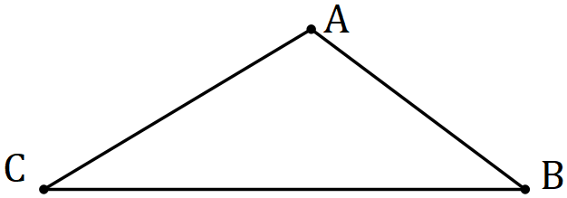

|  |
| --- |
| **Solution** |
|  |
| **Specific behaviours** |
| ✓ calculates the length correctly  ✓ correct to 1 d.p. (ft) |

(b) Show use of trigonometry to determine the size of angle in the triangle below, where and . (3 marks)

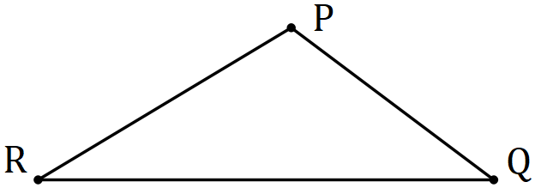

|  |
| --- |
| **Solution** |
|  |
| **Specific behaviours** |
| ✓ substitutes correctly into sine rule  ✓ correct value for  ✓ size of required angle (accept awrt 33) |

Question 11 (8 marks)

A hydroponic grower was trialling two different greenhouse systems for growing tomatoes. To compare the systems, the weight of tomatoes produced by each plant in the two greenhouses were recorded. The data is summarised below.

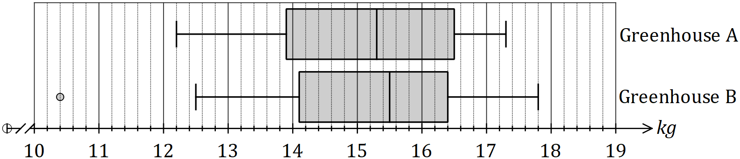

(a) Ignoring the outlier, compare the range of weights produced by plants in greenhouse with that of greenhouse . (2 marks)

|  |
| --- |
| **Solution** |
| The range of is smaller than that of . |
| **Specific behaviours** |
| ✓ indicates both ranges  ✓ comparison of ranges |

(b) State and use the interquartile ranges to compare the spread of weights produced by plants in greenhouse with that of greenhouse . (2 marks)

|  |
| --- |
| **Solution** |
| The spread of weights in is larger than the spread of weights in . |
| **Specific behaviours** |
| ✓ indicates both IQRs  ✓ comparison of spreads |

(c) Using the result of a relevant calculation, explain why one of the weights in greenhouse was identified as an outlier. (2 marks)

|  |
| --- |
| **Solution** |
| The weight of is an outlier as it is below . |
| **Specific behaviours** |
| ✓ calculates  ✓ states weight of outlier and that it is below cut-off |

(d) Is there evidence to support the conjecture that the system in one greenhouse produces a heavier crop of tomatoes than the other? Give reasons. (2 marks)

|  |
| --- |
| **Solution** |
| Yes, since  1. the median weight from exceeds that from and  2. the plant producing the largest crop was in greenhouse . |
| **Specific behaviours** |
| ✓ states yes with one reason  ✓ second reason |

Question 12 (7 marks)

Soup is sold in cylindrical tins that have an internal diameter of and a height of .

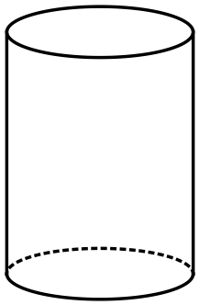

(a) Calculate the internal surface area of the closed can. (3 marks)

|  |
| --- |
| **Solution** |
|  |
| **Specific behaviours** |
| ✓ indicates correct radius  ✓ substitutes into formula  ✓ evaluates |

(b) Calculate the capacity of the can in millilitres. () (2 marks)

|  |
| --- |
| **Solution** |
|  |
| **Specific behaviours** |
| ✓ substitutes into formula  ✓ evaluates |

(c) Before the cans are sealed, they are stood on their circular end and filled with of soup. Determine the depth of soup in the can. (2 marks)

|  |
| --- |
| **Solution** |
|  |
| **Specific behaviours** |
| ✓ substitutes into formula  ✓ solves for |

Question 13 (7 marks)

Individual use coffee bags are packed in boxes of , or . Customers can buy cartons containing , or boxes, as shown in the following table.

|  |  |  |  |
| --- | --- | --- | --- |
| **Carton** | **Carton price ($)** | **Boxes per carton** | **Coffee bags per box** |
| **A** |  |  |  |
| **B** |  |  |  |
| **C** |  |  |  |

(a) A customer orders a total of cartons, comprising of type A, of type B and the rest of type C. Calculate the cost of this order, given that orders of more than qualify for a discount. (3 marks)

|  |
| --- |
| **Solution** |
|  |
| **Specific behaviours** |
| ✓ cost of A's and B's  ✓ cost of C's and total cost  ✓ correct cost with discount |

(b) Determine the cost of one coffee bag in each type of carton and hence list the carton types from best to worst value in terms of the price per coffee bag. (4 marks)

|  |
| --- |
| **Solution** |
| Best to worst: |
| **Specific behaviours** |
| ✓ calculates unit cost for carton A  ✓ calculates unit cost for carton B  ✓ calculates unit cost for carton C  ✓ correct ranking best to worst (based on seen unit costs) |

Question 14 (11 marks)

As part of an investigation into youth fitness, a researcher collected the sit-and-reach (SR) measurements of students. The data is summarised in the table below.

|  |  |
| --- | --- |
| SR measurement (cm) | Number of students |
|  |  |
|  |  |
|  |  |
|  |  |
|  |  |
|  |  |
|  |  |

(a) Use the mid-point of each class interval to determine the mean and standard deviation of the sit-and-reach measurements. (2 marks)

|  |
| --- |
| **Solution** |
|  |
| **Specific behaviours** |
| ✓ correct mean  ✓ correct sd |

(b) Explain why it was necessary to use the mid-point of each class interval to determine the statistics in (a). (1 mark)

|  |
| --- |
| **Solution** |
| Data has been grouped; No access to raw data; Best estimate for students in each interval; etc, etc |
| **Specific behaviours** |
| ✓ any reasonable explanation |

(c) Draw a histogram on the axes below to display the distribution of SR measurements.

(3 marks)

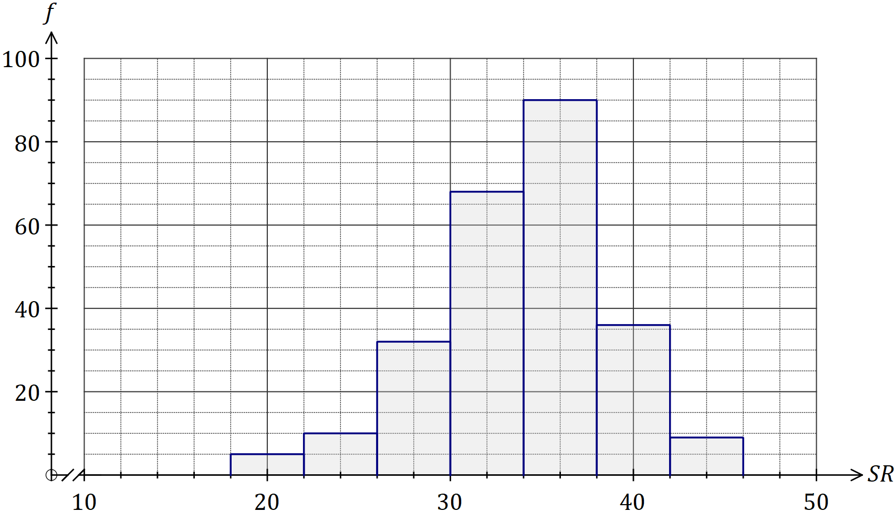

|  |
| --- |
| **Solution** |
| See graph |
| **Specific behaviours** |
| ✓ correct intervals  ✓ correct frequencies  ✓ lines drawn are straight |

(d) Use features of the histogram to describe the distribution of SR measurements for this group of students. (3 marks)

|  |
| --- |
| **Solution** |
| -The dataset is negatively skewed (skewed left).  -The dataset is unimodal, with the modal group.  -The bulk of measurements lie between 26 and 42 cm, with just a handful outside this interval.  -The frequencies increase up to the modal group and then decrease.  -There is no indication of any outliers.  -Etc etc |
| **Specific behaviours** |
| ✓ describes shape  ✓ describes modality  ✓ describes one other feature |

(e) In a previous investigation, the researcher found that the SR measurements for an older group of people were normally distributed with a mean of and a standard deviation of . Determine the percentage of people in this older group who had an SR measurement

(i) less than . (1 mark)

|  |
| --- |
| **Solution** |
|  |
| **Specific behaviours** |
| ✓ correct percentage |

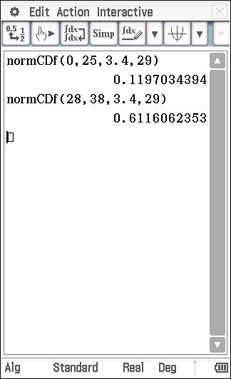

(ii) between and . (1 mark)

|  |
| --- |
| **Solution** |
|  |
| **Specific behaviours** |
| ✓ correct percentage |

Question 15 (8 marks)

The roof of a circular building has the shape of a right-circular cone with a base radius of and a perpendicular height of .

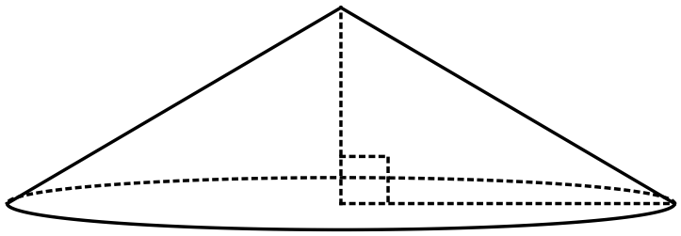

(a) Building regulations require that one air vent is required for every of space (or part) in the roof. Determine the number of air vents required for the roof shown. (3 marks)

|  |
| --- |
| **Solution** |
|  |
| **Specific behaviours** |
| ✓ substitutes correctly  ✓ correct volume  ✓ states required number of air vents |

(b) The curved surface of the roof is to be tiled (excluding the circular base). The tile that the builder has chosen has a coverage rate of tiles per square metre and can be bought in packs of . Determine the number of packs the builder must order. (5 marks)

|  |
| --- |
| **Solution** |
|  |
| **Specific behaviours** |
| ✓ calculates slant height  ✓ uses formula for curved surface area  ✓ calculates surface area  ✓ calculates number of tiles  ✓ calculates number of packs |

Question 16 (8 marks)

(a) The statistical investigation process is a cyclical process that begins with the need to solve a real-world problem and aims to reflect the way statisticians work. One of the four steps in the cyclical process involves the design and implementation of a plan to collect or obtain appropriate data.

(i) Describe the key elements of the step **immediately after** this step in the cyclical process.

(2 marks)

|  |
| --- |
| **Solution** |
| Select and apply appropriate graphical or numerical techniques to analyse the data. |
| **Specific behaviours** |
| ✓ indicates analysis  ✓ indicates use of graph or calculation |

(ii) Describe the key elements of the step **immediately before** this step in the cyclical process.

(2 marks)

|  |
| --- |
| **Solution** |
| Clarify the problem and formulate one or more questions that can be answered with data. |
| **Specific behaviours** |
| ✓ indicates clarify/identify problem  ✓ indicates formulation of question(s) |

(b) A student was carrying out a statistical investigation involving dogs.

(i) Describe an example of a categorical variable the student could investigate and list two different responses that could be recorded. (2 marks)

|  |
| --- |
| **Solution** |
| Type of breed: Poodle, terrier  Type of coat: Silky, wiry  Etc etc. |
| **Specific behaviours** |
| ✓ valid example relating to dogs  ✓ two different and valid responses |

(ii) Describe an example of a continuous numerical variable the student could investigate and list two different responses that could be recorded. (2 marks)

|  |
| --- |
| **Solution** |
| Weight: 8.5 kg, 7.2 kg  Length of tail: 5 cm, 56 cm.  Etc etc. |
| **Specific behaviours** |
| ✓ valid example relating to dogs  ✓ two different and valid responses with units |

Question 17 (9 marks)

A second-hand car yard paid for a vehicle and later sold it to a customer for .

(a) Calculate the percentage loss made on the sale. (2 marks)

|  |
| --- |
| **Solution** |
|  |
| **Specific behaviours** |
| ✓ calculates loss  ✓ correct percentage |

(b) The customer paid a deposit of and took out a loan for the remainder of the price with an interest rate of per annum. Calculate the simple interest on the loan for the first month. (3 marks)

|  |
| --- |
| **Solution** |
|  |
| **Specific behaviours** |
| ✓ calculates principle  ✓ interest for one year  ✓ interest for one month |

(c) The price the customer paid included GST. Calculate the amount of GST included in the price. (2 marks)

|  |
| --- |
| **Solution** |
|  |
| **Specific behaviours** |
| ✓ correct method  ✓ amount of GST |

(d) The standard premium to insure the vehicle was , but the customer was offered a discount of for not having made any claims over the past five years. Determine the premium after the discount was applied. (2 marks)

|  |
| --- |
| **Solution** |
|  |
| **Specific behaviours** |
| ✓ correct method  ✓ correct premium |

Question 18 (8 marks)

The top of a vertical pole stands above a surrounding level playing field. The angle of depression from to a small animal at is . The animal leaves , moves directly towards the base of the pole and stops at (before reaching ). The distance is .

(a) Sketch a diagram to show the above information. (2 marks)

|  |
| --- |
| **Solution** |
|  |
| **Specific behaviours** |
| ✓ vertical with angle of depression to  ✓ lengths and , making a right-angle |

(b) Calculate the line of sight distance from the top of the pole to . (2 marks)

|  |
| --- |
| **Solution** |
|  |
| **Specific behaviours** |
| ✓ uses sine ratio  ✓ correct distance |

(c) Determine the angle of depression from to . (2 marks)

|  |
| --- |
| **Solution** |
|  |
| **Specific behaviours** |
| ✓ uses tangent ratio  ✓ correct angle (to nearest degree) |

(d) Calculate the distance travelled by the animal from to . (2 marks)

|  |
| --- |
| **Solution** |
|  |
| **Specific behaviours** |
| ✓ calculates  ✓ calculates |

Question 19 (7 marks)

The wind chill index is a measure of how quickly a person exposed to a wind will lose heat. It is calculated using the formula below, where is the speed of the wind in metres per second and is the air temperature in degrees Celsius.

(a) Determine when the air temperature is and there is a wind of blowing.

(2 marks)

|  |
| --- |
| **Solution** |
|  |
| **Specific behaviours** |
| ✓ correct substitution  ✓ evaluates (award full marks if CAO) |

(b) Calculate the change in the wind chill index when the air temperature is and the strength of the wind decreases from to . (3 marks)

|  |
| --- |
| **Solution** |
|  |
| **Specific behaviours** |
| ✓ first value correct  ✓ second value correct  ✓ indicates decrease and states amount |

(c) A person is likely to suffer from frostbite when the wind chill index reaches . At what temperature will this happen, on a day when the wind has a speed of? (2 marks)

|  |
| --- |
| **Solution** |
|  |
| **Specific behaviours** |
| ✓ substitutes correctly in equation  ✓ solves for temperature (ft) – award full marks if CAO |

Question 20 (7 marks)

A model of a triangular gable has measurements shown below, in centimetres.

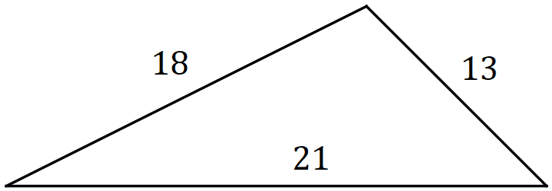

(a) Use Heron's rule to determine the area of the model of the gable, correct to 1 decimal place, showing how the formula is applied. (3 marks)

|  |
| --- |
| **Solution** |
|  |
| **Specific behaviours** |
| ✓ calculates semi-perimeter  ✓ substitutes values correctly into Heron's rule  ✓ correct area (to at least 1dp) |

The model was drawn to a scale using measurements taken from a building, where the length of the shortest side of the gable was .

(b) Calculate the scale factor used to draw the model. (1 mark)

|  |
| --- |
| **Solution** |
|  |
| **Specific behaviours** |
| ✓ correct scale factor |

(c) The gable on the building requires repainting, at a cost of per square metre. Determine the cost of repainting the gable, to the nearest dollar. (3 marks)

|  |
| --- |
| **Solution** |
|  |
| **Specific behaviours** |
| ✓ indicates area scale factor  ✓ building area  ✓ calculates cost, rounding |

Question 21 (8 marks)

When working out the cost of building an in-ground swimming pool, a contractor calculates a shape factor to use in a spreadsheet, where

is the perimeter of the pool in metres and is the area of the pool in square metres.

Pool 1 is rectangular with a semi-circular end and pool 2 is rectangular with a cut-out as shown.

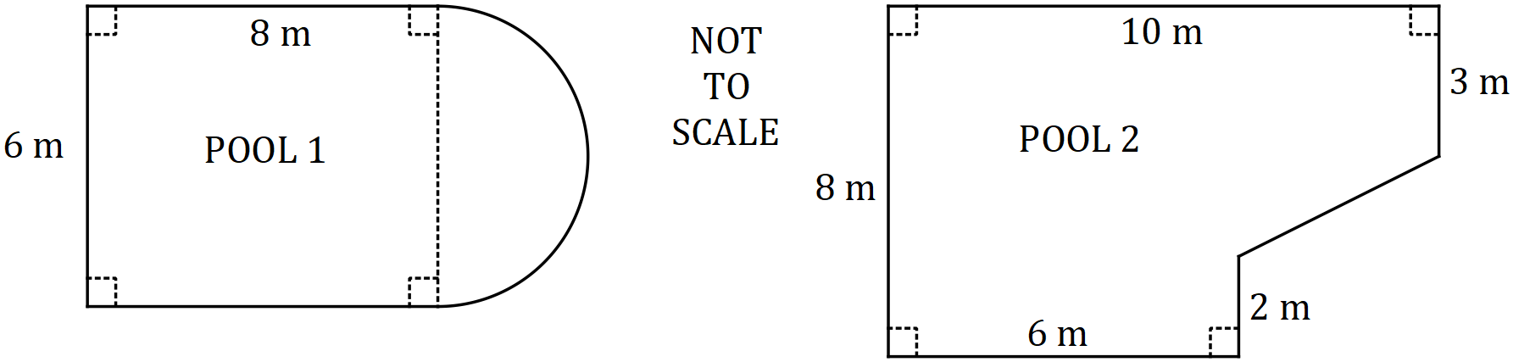

Determine, with justification, which of the pools shown has the larger shape factor .

|  |
| --- |
| **Solution** |
| Pool 1  Pool 2  Pool 2 has the larger shape factor. |
| **Specific behaviours** |
| ✓ area of pool 1  ✓ perimeter of pool 1  ✓ for pool 1  ✓ area of pool 2  ✓ indicates missing length in pool 2  ✓ perimeter of pool 2  ✓ for pool 2  ✓ identifies pool with larger |

Supplementary page

Question number: _________

Supplementary page

Question number: _________

Supplementary page

Question number: _________

© 2018 WA Exam Papers. Kennedy Baptist College has a non-exclusive licence to copy and communicate this document for non-commercial, educational use within the school. No other copying, communication or use is permitted without the express written permission of WA Exam Papers. SN245-123-4.